Project Development Phase
Performance Test

Date | 19 July 2026
Team ID
Project Name
Maximum Marks

Model Performance Testing:
S.No. | Parameter | Screenshot / Values
1 | Data Rendered | 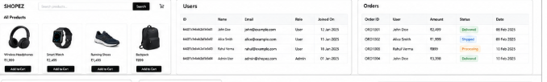
2 | Data Preprocessing | 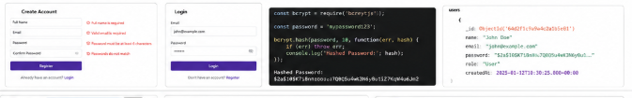
3 | Utilization of Filters | 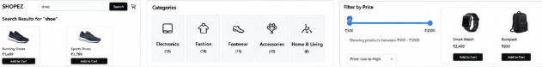
4 | Calculation Fields Used | 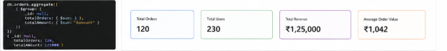
5 | Dashboard Design | 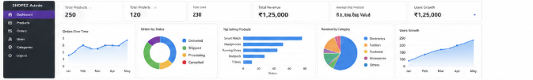
6 | Story Design | 